MyMPIScan
What have we done?
The implementation will do a distributed computation of n prefix sums from the input file f where n is defined as unsigned long and therefore allowing large data arrays to be computed.

Every node will read the file's size and wait for data from the left node (left node's rank rank = current node's rank -1) and after receiving the full data array the node will forward the data to the right node (right node's rank = current node's rank +1).
Exceptions to this rule is the root node (rank = 0) which will read the file f and send the data to itself.
Also the last node (rank = communicator.size-1) will not forward the data array as all other nodes already got the data.

After data is received each node will calculate it's local block's prefix sums. The local block is determined from a node's rank and the block-size which is calculated by dividing the total length of the data divided by the total number of nodes in the communicator.

After a node's local processing is done, it will wait till it receives data from the left node. Data received contain all previously computed global prefix sums from index 0 to the current node's rank-1.
After this data have been received, the local node will add the last received sum to it's local prefix sum result creating a correct global result of all nodes from root to this node inclusive.
Again the root node is an exception as it wont receive any data in this step.

After computation the node will send all data to the right node and terminate.
In order to get the whole result back to the root node, the highest ranked node will send it's data back to the root node, which unlike all others wont terminate after sending off the data array.

Correctness of the program is assured by using the input file with one of the openMP prefix(sum) programs, or if in doubt with the sequential calculator that is also a part of the prefix package.

The running time of our algorithm is O((n/p)+(n/p)) – once for calculating the local prefix sums and once for adding the global sum - assuming that all nodes are equally fast and the work is equally distributed.
To achieve this as good as possible the block-size is determined after the size of the input and the total number of nodes is known.
There are still corner cases where the last node(s) will have less or nothing to do and just be there to relay messages.

There is also the compile-time option DEBUG which makes the program pretty verbose. Later we noticed strange mpirun behavior so that we needed to limit n (the size of our data array) to a maximum of 64, which was enough for debugging and does not lead to output being discarded.

The original behavior of DEBUG can be restored by using the compile-time option XDEBUG.

What have we not done / What does not work?
There was by far not enough time to make a great MPI program so we had to cut some use-cases we wanted to test.
One of these was a comparison of multiple processes on one machine vs one process and a parallel algorithm for local prefix sum computation.
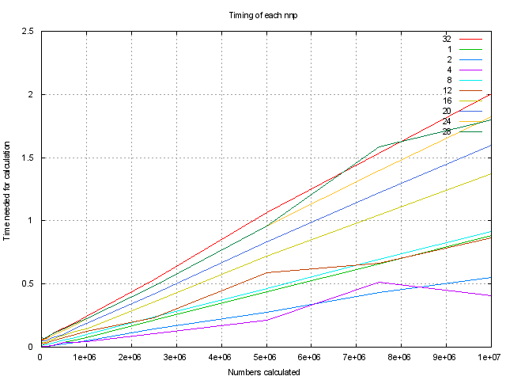
Another shortcoming is that we wanted to have a distributed system where only one node needs access to the resource file. This was just partially achieved: the root node will read the input-file and nodes will pass the work to each other. What was forgotten: the size of the data array is determined by stat'ing the input-file, which is why all nodes still need to have access to the input file.

As we ran out of time, we were not able to do fine grained runs, which makes our figures look pretty straight, hopefully we will be able to provide more fine grained figures at the presentation.

What we wanted to show?
The goal was to show that distributed computation will be faster than the sequential solution. The problem that we encountered was that there was by far more overhead than expected and the MPI prefix sum calculation was always outperformed by it's sequential counterpart.
Maybe we should have used a more resource intensive operation than a simple addition?
Another aspect we wanted to test was to see, how big data arrays we can run through the system as one is often confronted with int-arrays, we went for unsigned long arrays.

How is this solution different form MPI_Scan?
The result is sent back to the root node and there is only need for one array, allowing us to read and process more data with the same amount of RAM.

Figures
These two figures show the processing time needed in the aspect of changing node and n counts.
With one processor per node we get much better performance than with 16.
This is most likely because of the competition for computation power between us and this course's other students.


