Merge
What have we done?
We implemented a parallel merge-sort that merges two per-sorted arrays and reports the time needed.
It takes as an argument the number of slices, to which the first array is split. For every block of the first array the corresponding block in the second array is found by calling the function 'rank' on the second array.
This implementation is able to merge arrays containing elements with the same value.

What have we not done / What does not work?
The algorithm does only work if the size of the first array is a multiple of the number of slices.
The binary search algorithm does not work, so the time needed is O((n/p)+m+log n).

What we wanted to show?
The speedup in computation time when using multiple cores instead of a sequential solution with large arrays.

Figures
The first figure shows the time needed to merge in relation to the number of slices.
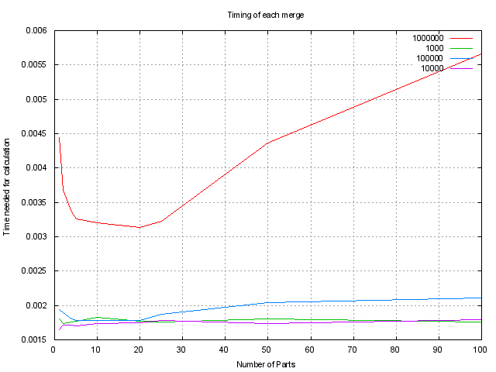

We can see for one that if we use more cores, the time needed for merging goes down (which shows that the algorithm can be parallelized) and that if we create more slices than we have cores available the overhead of finding the bounds of the block in the second array increases as the function 'rank' is called twice for each block.
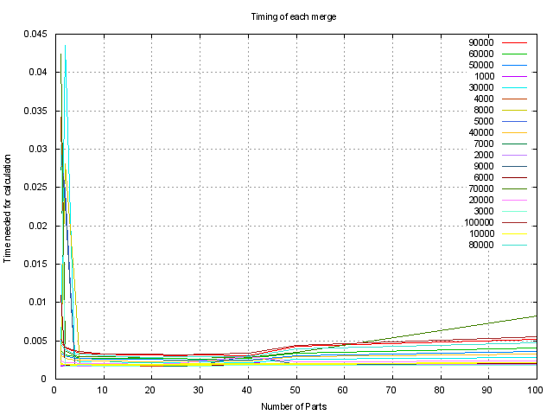
We can see this tendency even better in the following plot, which is run with a bigger variety of array sizes to be merged.

